Template for Evidence(s)
SAMPLE
UI GreenMetric Questionnaire

University : ...
Country : ...
Web Address : …

[1] Setting and Infrastructure (SI)

[1.18] Conservation: plant, animal, and wildlife, genetic resources for food and agriculture secured in either medium or long-term conservation facilities (SI.8)

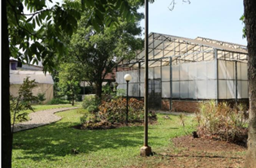 |  | 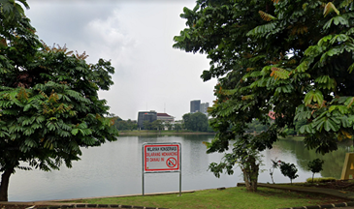
Green House (Telkom University) | Danau Kenanga (Universitas Indonesia)
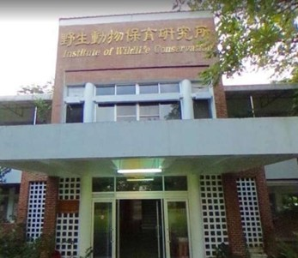 | 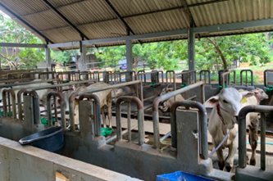
NPUST Institute of Wildlife Conservation | Cattle Farming
Example of Conservation: plant, animal, and wildlife, genetic resources for food and agriculture secured in either medium or long-term conservation facilities

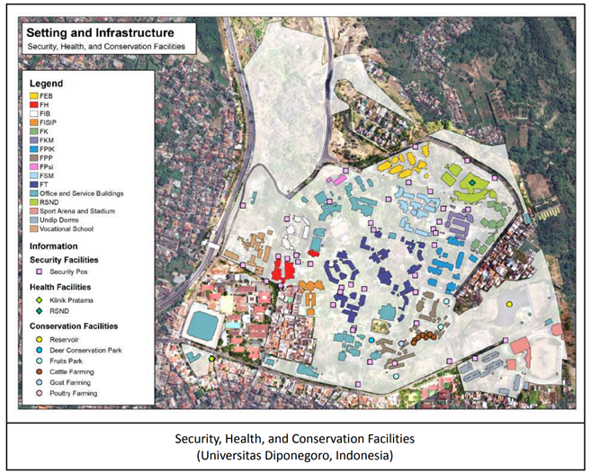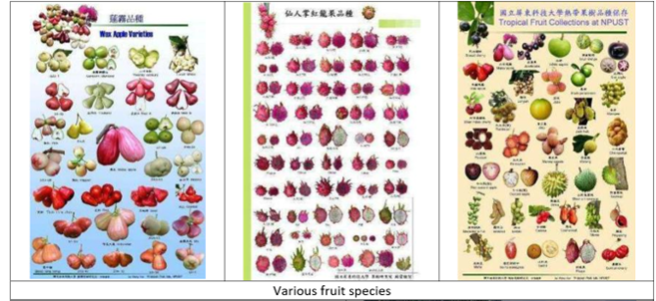

Description:
(Please describe the Conservation: plant, animal, and wildlife, genetic resources for food and agriculture secured in either medium or long-term conservation facilities in your campus. The following is an example of the description. You can describe more related items if needed.)

- Green house for planting vegetables for campus residents
- Danau Kenanga for fish conservation area
- NPUST Institute of Wildlife Conservation
- Cattle Farming at Universitas Diponegoro

Additional evidence link (i.e., for videos, more images, or other files that are not included in this file):

